Automating Employee Data

Introduction
The Automating Employee Data project aims to modernize employee record management. It eliminates manual data entry and reduces repetitive administrative tasks. The system centralizes employee information into a unified platform. It automatically captures and updates key details such as roles and departments. It supports real-time updates for better organizational visibility. It enhances efficiency and simplifies workforce data management.
Process
Steps for Creating Employee Record
- Create an Employee record with the fields Name, Email, Department, Manager and Manager Email using Google Sheets.
- Download the file as Employee data.xlsx.
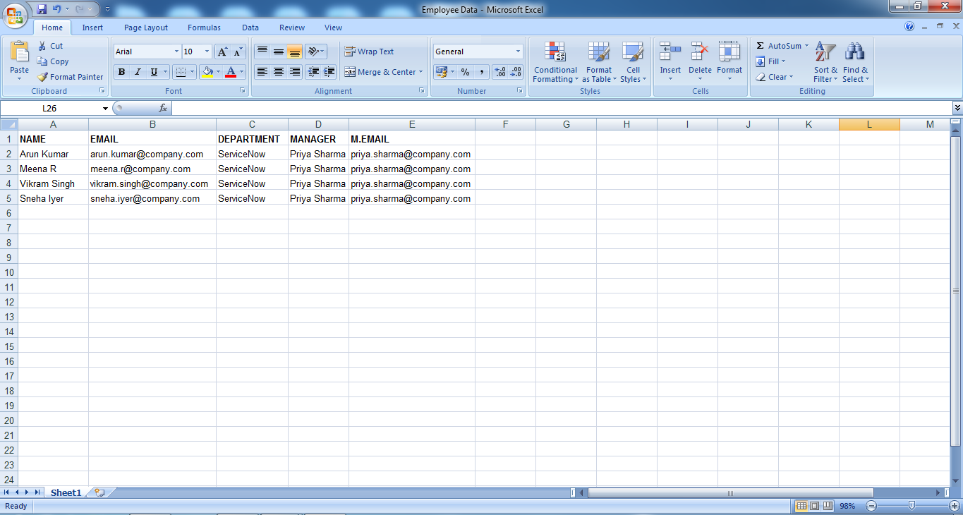
Steps for Importing Data
- Open Service Now.
- Click on All →System Import Sets →Load Data.
- Select create table.
- Give the import set table name as: import employee.
- Choose the file which we created in the XL sheet.
- The data is imported, click on personalized list and add Fields.
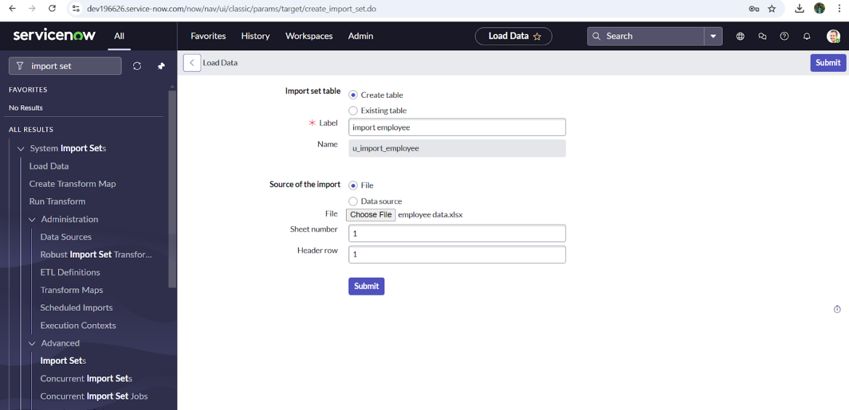
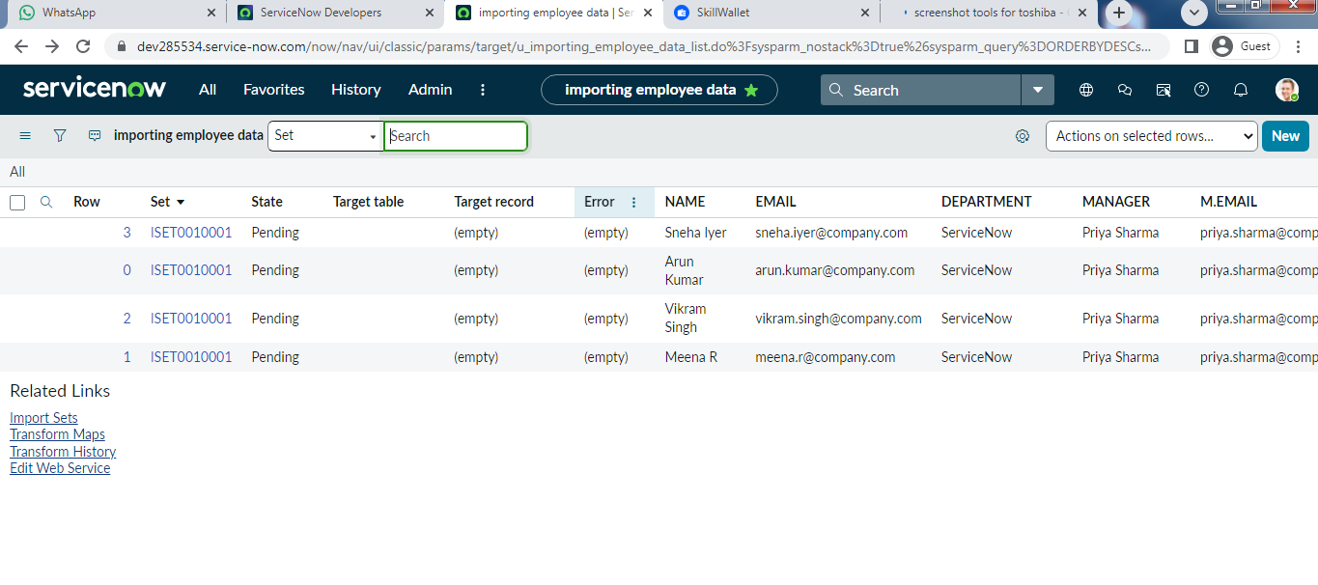
Steps for Creating Transform Map
- Open Service Now.
- Click on All →System Import Sets →Create Transform Map.
- Click on New and Fill the details to create a new transform map.
- Give name as: Employee data transform.
- Select source table as Importing employee data
- Select target table as User [sys_user] and save the form.
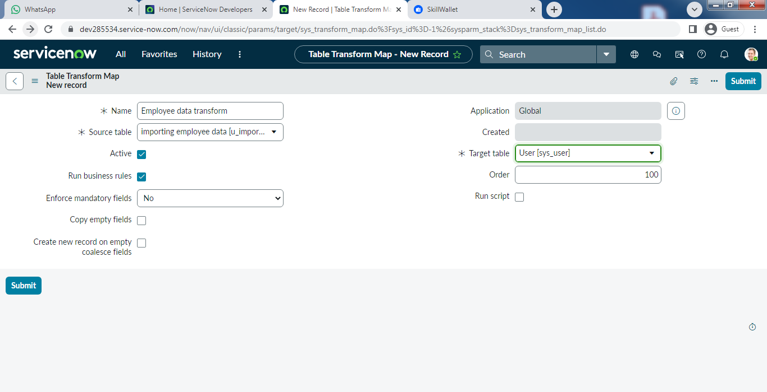

Steps for Matching the Fields
- Scroll down the created Transform map and click on Auto Matching Fields. Then the mapping fields are matched. 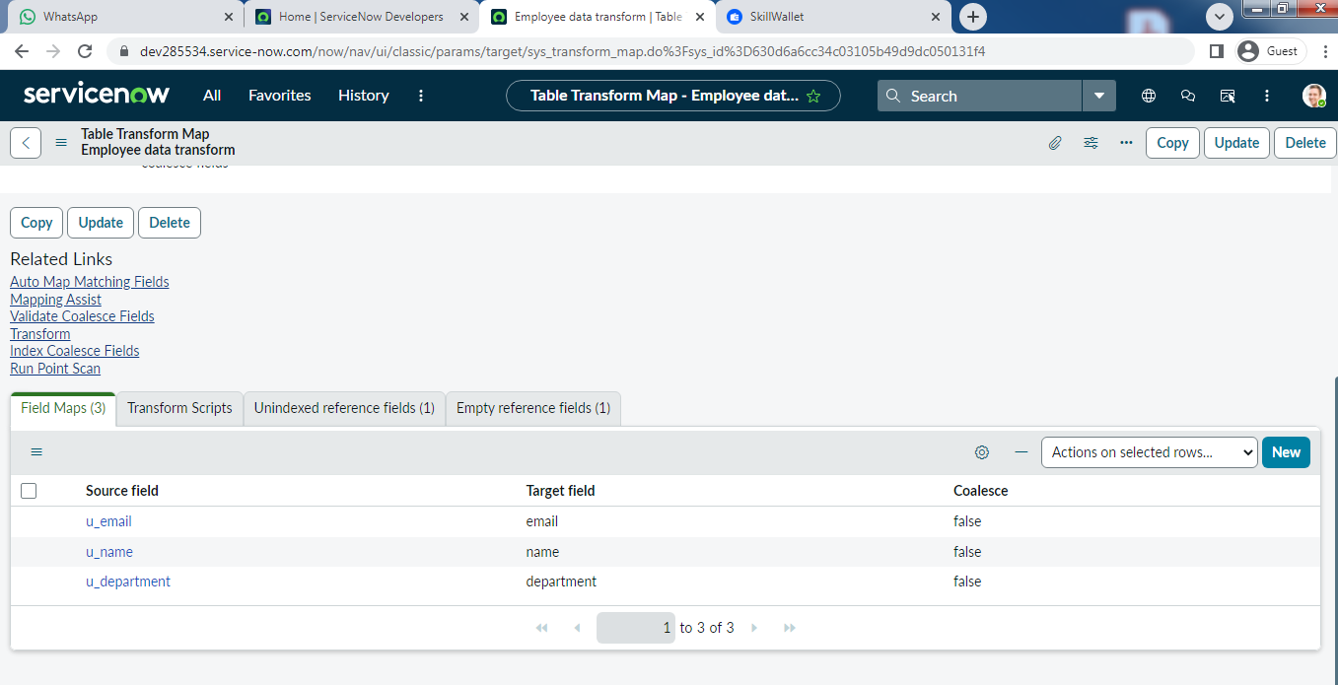
- Click on Mapping Assist and map the Manager Field.
- Select Manager in source table.
- Select Manager Fields in target table and click on save button.

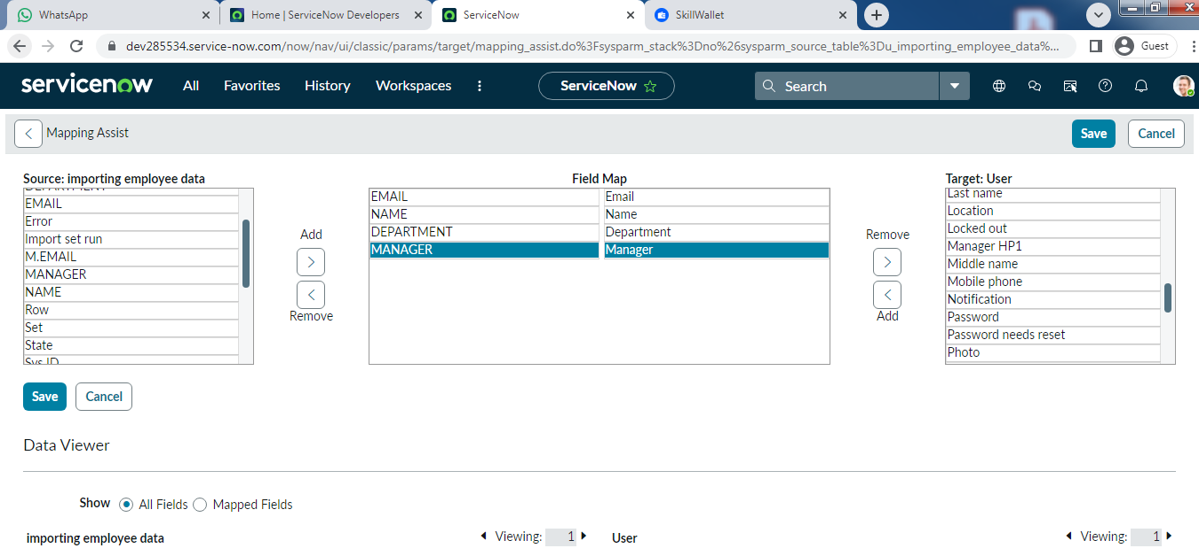
Steps for Transforming Data
- Click on Transform in the Related Links.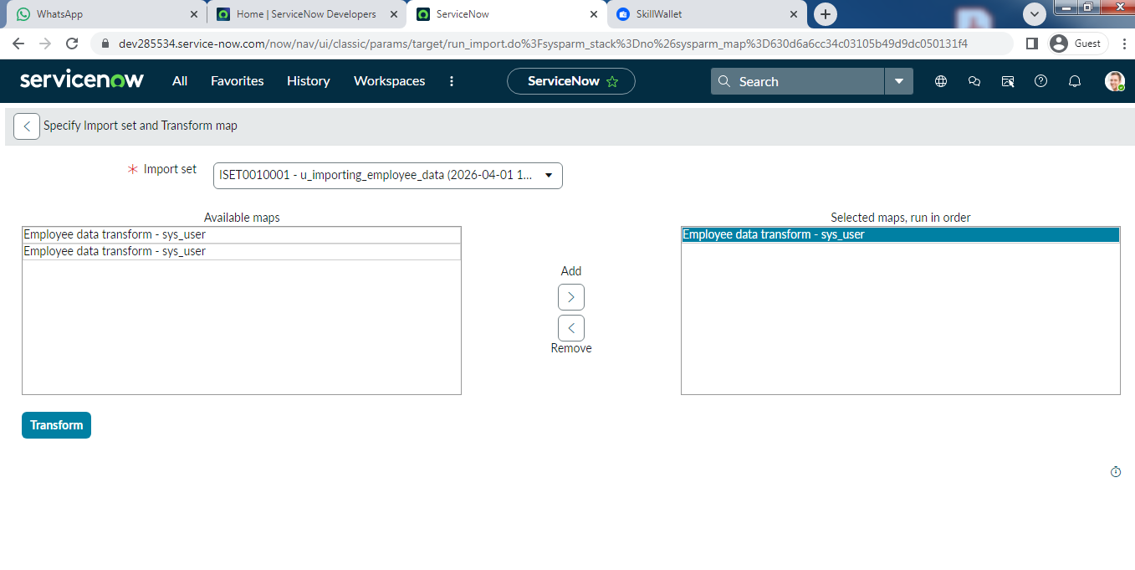
- Click on the Transform button and the data transform state is completed.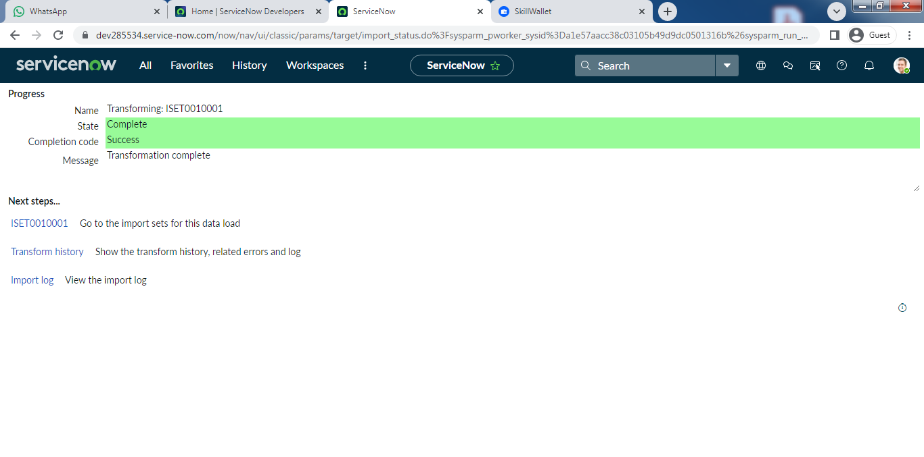
- Click on ISET0010001 under next steps.
- Four rows are inserted.
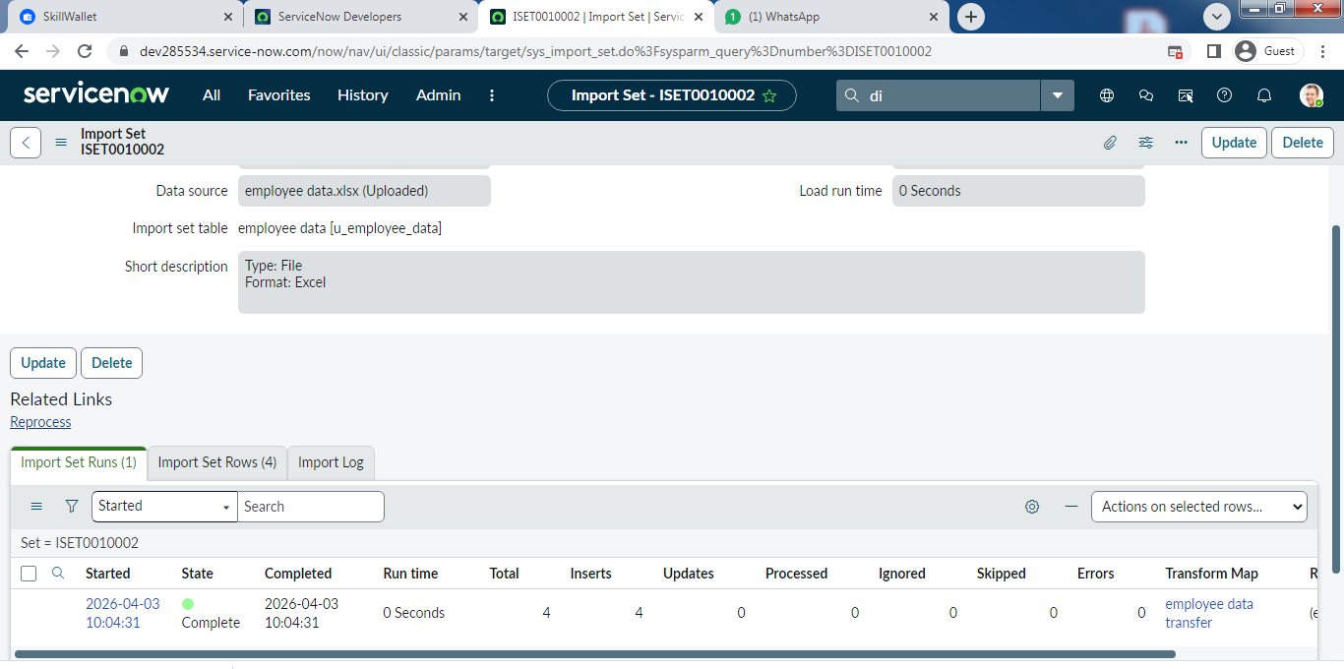

Steps for Dot Walking
- Open Service Now.
- Click on All →Incident →Create New.
- There is no field like department in the form.
- Click on menu →Configure →form layout.
- Select Assigned to.Department, Assigned to.Email and Assigned to.Manager to the selected Fields and save the form layout.
- Open an Incident form and fill the mandatory fields and assigned to field with the imported user(Eg.Arunkumar).
- Then the Department, Email and the Manager fields are filled automatically.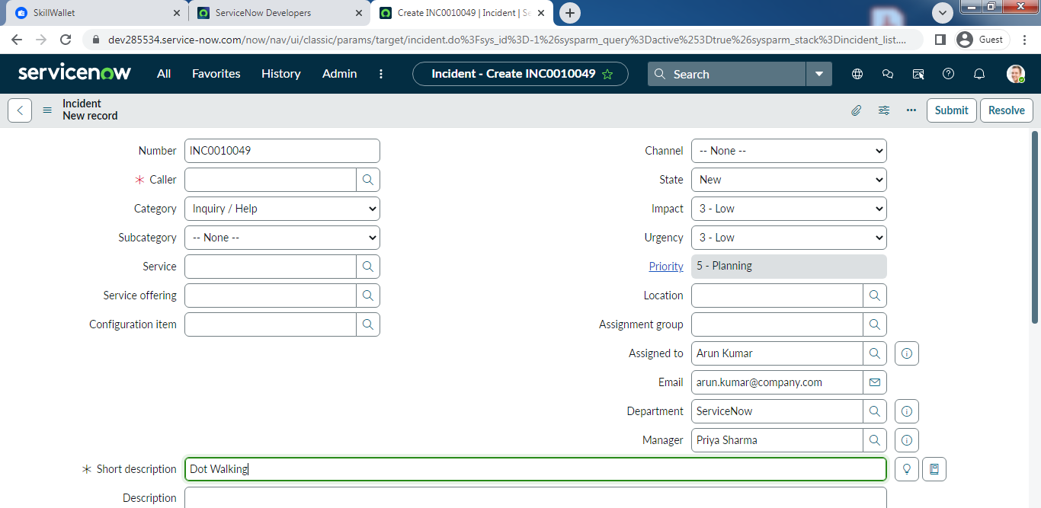
Steps for Dictionary Override
- Click on All →System Definition →Tables.
- Create a table with table name as Incident table and set Extends table=Task.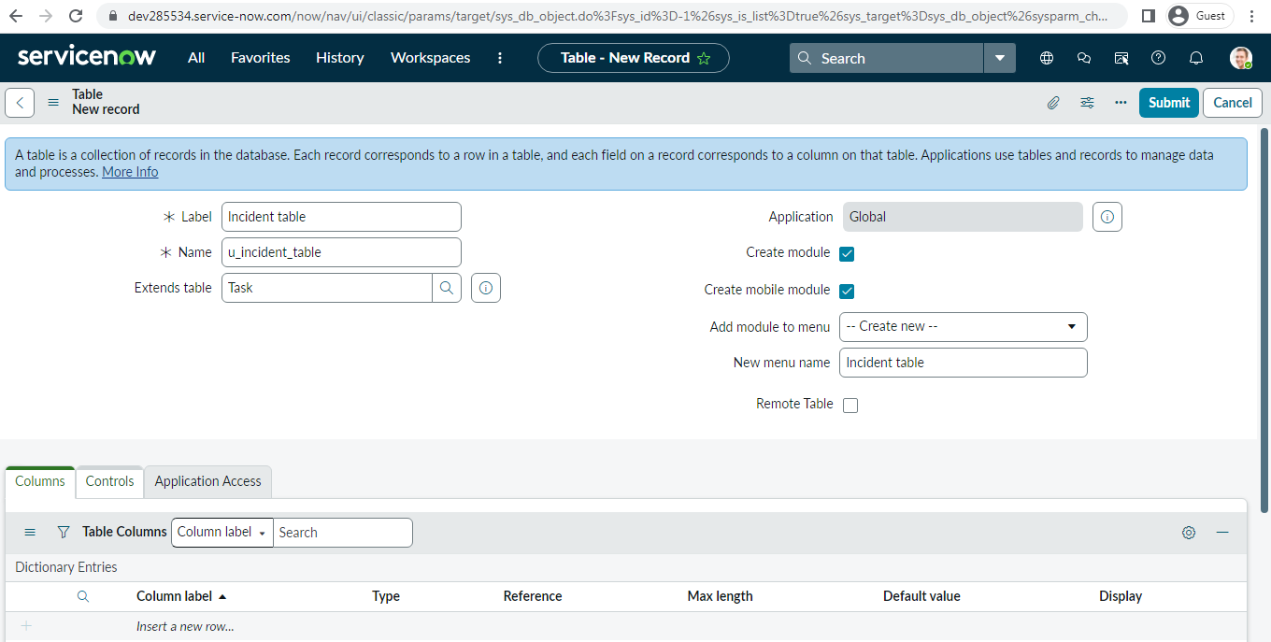
- Open the Incident table.
- Go the Priority columns and notice that the default value is inherited from task table (4-Low).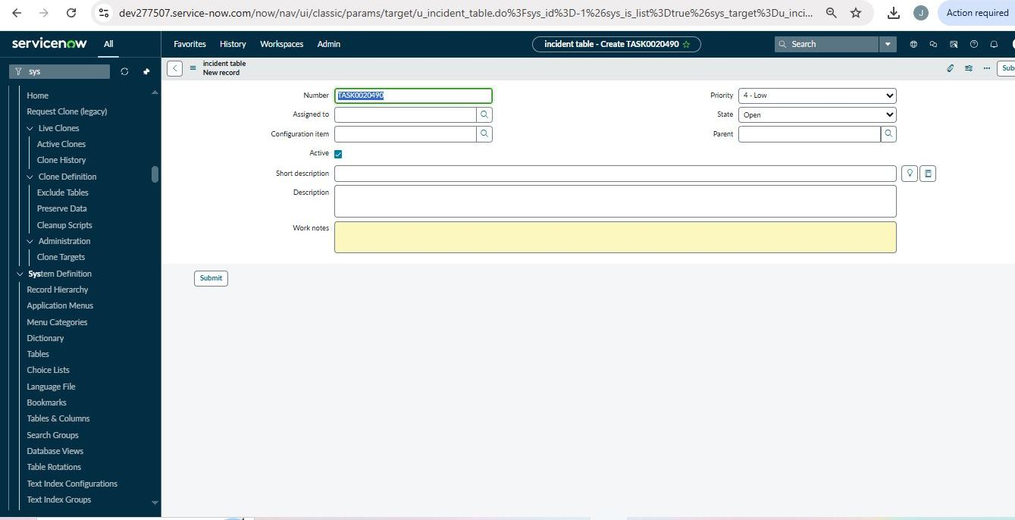
- Open the Dictionary Override →New.
- Fill the table name as created Table and column name as Priority.
- Check the Override Default value and set is as 3 and submit.
- Open a new Incident Record and verify the priority defaults to 3-moderate.
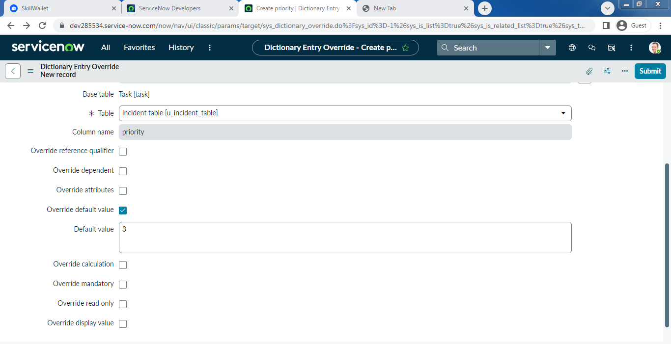
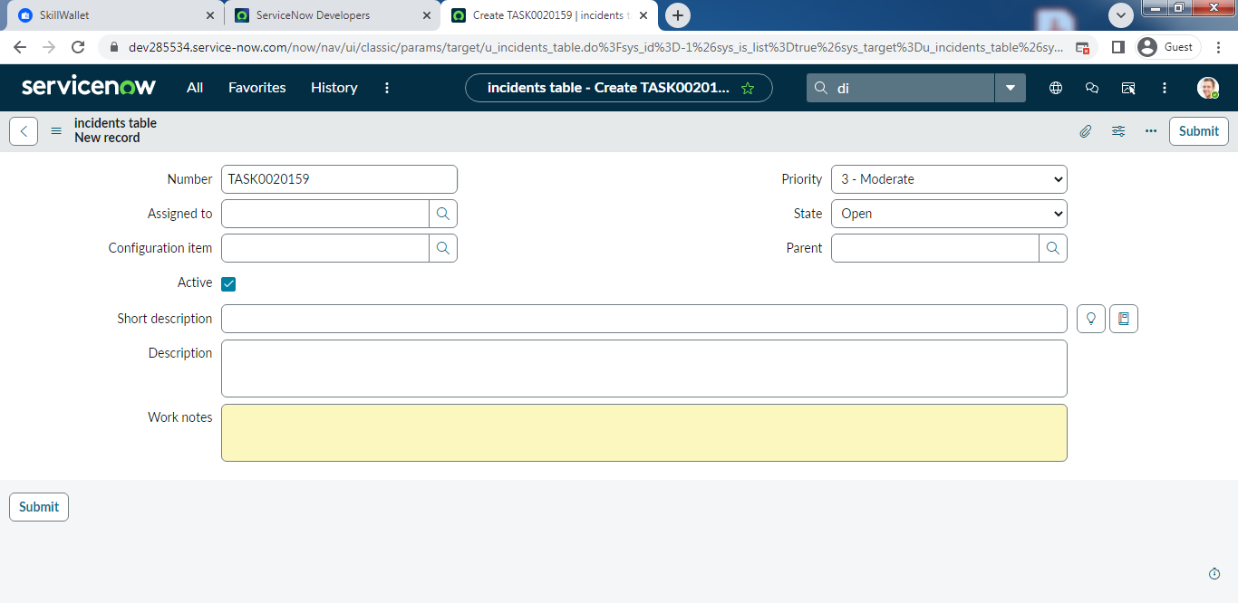
Conclusion
The Automating Employee Data project delivers a reliable and efficient data management solution. It significantly reduces manual workload through intelligent automation. The system ensures high accuracy and consistency of employee records. The solution is scalable and adaptable to future needs. In conclusion, it transforms employee data management into a streamlined and effective process.

